Ideation Phase
Brainstorm & Idea Prioritization
Date | 04 October 2026
Team ID | SWTID-2026-6870
Project Name | Streamlining IT Procurement: Automating Standard Laptop Orders with Flow Designer
Maximum Marks | 4 Marks

Brainstorm & Idea Prioritization
Brainstorming gave the team a free and open space to list ideas for improving the IT procurement process. Volume was preferred over perfection first, then the ideas were grouped and ranked by impact and effort.

Step-1: Team Gathering, Collaboration and Select the Problem Statement
The team met to review how standard laptop requests are handled today. The problem statement selected for the project is:
Selected problem: Standard laptop orders need configuration, but the configuration task is created and assigned manually. This step is easily missed or delayed, so users wait longer and the IT department uses its people inefficiently.

Role | Responsibility in brainstorming
IT procurement representative | Explained how laptop orders are raised and approved
Hardware team representative | Explained how laptops are configured and what information the task needs
ServiceNow developer (project owner) | Suggested platform features (Flow Designer, Service Catalog) that can automate the process
Team members: [add your team member names here].

Step-2: Brainstorm, Idea Listing and Grouping
Group | Ideas listed
Automation | Use Flow Designer to react to every Standard Laptop order  Create the configuration task automatically with the Create Catalog Task action  Set the short description and description automatically
Assignment | Assign the task to the Hardware group automatically  Round-robin assignment inside the Hardware group  Escalate if a task stays unassigned
Approval & tracking | Keep the approval step in the Service Catalog request  Show the generated task under the Requested Item  SLA dashboard for configuration time
Communication | Email the requester when the task is created  Notify the Hardware team on new tasks  Status updates on the request
Alternatives (rejected) | Manual checklist for IT staff  Build a separate custom application from scratch

Step-3: Idea Prioritization
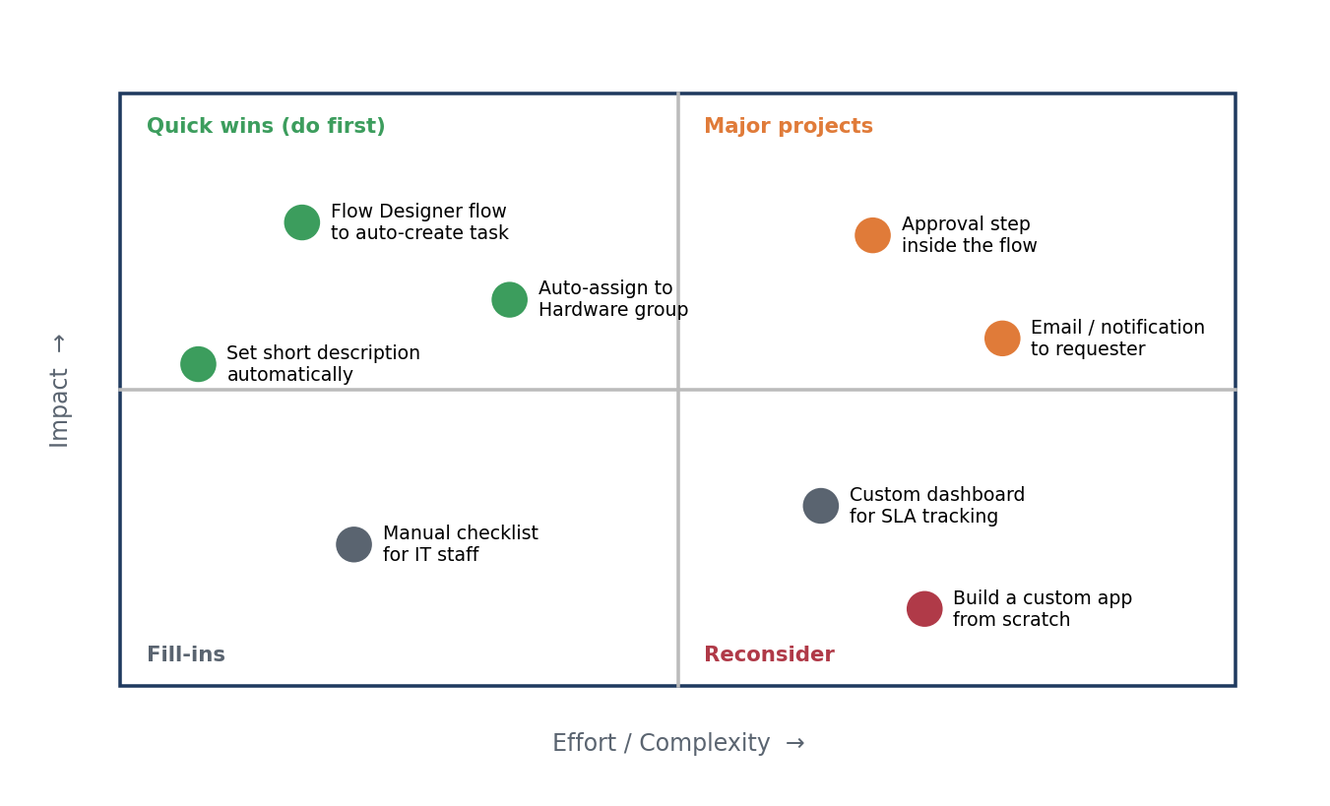
Figure 1: Impact vs effort matrix of the brainstormed ideas
No. | Idea | Impact | Effort | Decision
1 | Flow Designer flow triggered from Service Catalog | High | Low | Selected – core of the project
2 | Create Catalog Task action with fixed short description | High | Low | Selected
3 | Auto-assign task to Hardware group | High | Low | Selected
4 | Approval handling on the request (approver approves REQ) | Medium | Low | Selected
5 | Email notification to requester | Medium | Medium | Future scope
6 | SLA / dashboard reporting | Medium | High | Future scope
7 | Custom application from scratch | Low | High | Rejected

